

Smart Green House Monitoring System

CSC328: Introduction to Internet of Things (IoT)

Spring Semester (2024 - 2025)

Hania Seif Eldeen

80220110

*May 16, 2024*

**Abstract**

This research project focuses on the development of an Internet of Things (IoT) system for smart greenhouses, aiming to enhance agricultural practices through automation and intelligent monitoring. With the increasing demand for sustainable food production and the challenges posed by climate change, smart greenhouse technology emerges as a promising solution.

The background of the project addresses the necessity for efficient resource utilization in agriculture, emphasizing the need for precision farming techniques to optimize crop yield while minimizing resource wastage. Additionally, it discusses the limitations of traditional greenhouse systems in adapting to dynamic environmental conditions and providing real-time insights for effective decision-making.

The primary aim of the project is to design and implement an integrated IoT framework that enables remote monitoring and control of essential greenhouse parameters such as temperature, humidity, soil moisture, and light intensity. By leveraging sensor data and actuators, the system intends to create an environment conducive to plant growth while reducing manual intervention.

Expected results include improved crop yield, resource efficiency, and reduced operational costs through automated control and optimization.

**Keywords:** Smart Green House, Automated, Agriculture, IoT

**Table of Contents:**

Abstract……………………………………………………………………………………………2

Table of Contents………………………………………………………………………………….3

Introduction…………………………………………………………………………………….....4

Problem Statement……………………………………………………………………………..4

Significance of the Study………………………………………………………………………4

Project Aims and Objectives…………………………………………………………………...4

Project Questions………………………………………………………………………………4

Literature Review………………………………………………………………………………….5

Contribution……………………………………………………………………………………….6

Simulation…………………………………………………………………………………………8

Conclusion……………………………………………………………………………………….12

Future Plans……………………………………………………………………………………...12

References………………………………………………………………………………………..13

**Introduction**

**Problem Statement:**

Traditional greenhouse farming methods face challenges in adapting to dynamic environmental conditions, resulting in suboptimal resource utilization and productivity. Manual monitoring and control systems are often inefficient and unable to provide real-time insights for effective decision-making, leading to increased operational costs and reduced crop yield. Addressing these limitations requires the integration of advanced technologies such as IoT to create smart greenhouse systems capable of autonomous operation and intelligent resource management.

**Significance of the Study:**

The significance of this study lies in its potential to revolutionize agricultural practices by leveraging IoT technology to develop smart greenhouse systems. By enhancing automation and monitoring capabilities, these systems can optimize resource usage, improve crop yield, and contribute to sustainable food production. Furthermore, the implementation of IoT in agriculture offers opportunities for cost reduction, environmental conservation, and resilience against climate change-induced challenges.

**Project Aims and Objectives:**

The primary objective of this project is to create an IoT-based system tailored for smart greenhouses, with a core focus on facilitating remote monitoring and control of crucial environmental parameters. To achieve this goal, the project sets out specific objectives. Firstly, it aims to gain a comprehensive understanding of the prerequisites and obstacles inherent in traditional greenhouse farming methods. Building upon this knowledge, the project endeavors to design an integrated IoT framework equipped to efficiently gather, transmit, and analyze sensor data. Key to this framework is the implementation of actuators, allowing for automated regulation of greenhouse conditions including temperature, humidity, soil moisture, and light intensity. Finally, the project seeks to validate the efficacy of the developed system through rigorous field trials and meticulous data analysis, ensuring its practical viability and effectiveness in real-world agricultural settings.

**Project Questions:**

1. How can IoT technology be leveraged to address the challenges faced by traditional greenhouse farming methods?
2. What are the key components and functionalities required for an effective IoT-based smart greenhouse system?
3. What are the potential benefits and challenges associated with implementing IoT in agriculture, particularly in the context of smart greenhouse systems?
4. What are the implications of this research for sustainable food production, resource efficiency, and climate change adaptation in agriculture?

**Literature Review**

In this section, we delve into a comprehensive analysis of various previous studies to gather insights on the said system. [1] introduces the application of IoT technology in agriculture, specifically focusing on smart greenhouse systems. It discusses the motivation behind developing such systems, highlighting challenges in traditional agriculture and the potential benefits of automation. The technical description includes explanations of IPV4 and MAC addressing, subnetting, and various IoT components and systems such as temperature monitoring, humidity monitoring, fire safety, Carbon Dioxide (CO2) detection, smart lighting, soil moisture monitoring, solar energy generation, smart door, and smart security systems. Advantages and disadvantages of IoT devices in agriculture are discussed, along with suggestions for future enhancements, such as predictive modeling and integration with weather application program interfaces (APIs). The paper concludes by emphasizing the significance of smart greenhouse systems in enhancing agricultural productivity and providing references for further exploration of the topic.

[2] explores the application of IoT technology in greenhouse farming to enhance sustainability and productivity. The authors emphasize the role of sensors and IoT in monitoring various parameters crucial for plant growth and health, such as humidity, temperature, nutrient levels, CO2 concentration, and pest control. They introduce a Decision Support System (DSS) to coordinate and manage these activities efficiently. Additionally, the paper addresses challenges in traditional greenhouse farming, including nutrient management, environmental monitoring, disease detection, and data collection, proposing an IoT-based solution to automate and optimize these processes. By leveraging IoT frameworks for data acquisition, centralized management, and automation, the proposed system aims to create a more sustainable and efficient greenhouse environment conducive to plant growth and production.

In this project, we implemented a networked system of sensors and actuators to monitor and control environmental parameters crucial for plant growth, including temperature, humidity, soil moisture, CO2 levels, and fire safety. The system integrates smart features such as smartphone monitoring, Radio Frequency Identification (RFID)-based access control, and solar energy generation for sustainability. Through a detailed methodology and flowchart, the project demonstrates the seamless coordination of sensors and actuators to maintain optimal greenhouse conditions.

**Contribution**

Our research project, "Smart Greenhouse Monitoring System” makes a significant contribution to the field of IoT applications in agriculture and environmental monitoring. The project focuses on leveraging IoT technology to create an intelligent greenhouse system capable of autonomously monitoring and controlling various environmental parameters critical for plant growth.

1. **Innovative System Design**: Our project introduces an innovative system design implemented in Cisco Packet Tracer, integrating a network of sensors and actuators to create a comprehensive greenhouse monitoring system (Figure 1). By incorporating sensors for temperature, humidity, soil moisture, CO2 levels, and fire detection, coupled with actuators for controlling environmental variables, we provide a holistic solution for greenhouse management.
2. **Real-time Monitoring and Control**: Through the integration of IoT principles, our system enables real-time monitoring and control of greenhouse conditions remotely. Utilizing wireless connectivity and smartphone applications, users can access critical data on environmental parameters and control actuators to maintain optimal growing conditions from anywhere with internet access.
3. **Environmental Sustainability**: A key highlight of our project is its emphasis on environmental sustainability. By integrating solar energy generation, our system reduces dependency on conventional power sources, making greenhouse operations more ecofriendly and cost-effective in the long run.
4. **Enhanced Safety and Security**: We address safety and security concerns in greenhouse management through the implementation of fire detection systems and smart door access control. By integrating smoke detectors, fire sprinklers, and RFID-based door locking mechanisms, our system enhances safety measures and mitigates potential risks associated with fire hazards and unauthorized access.

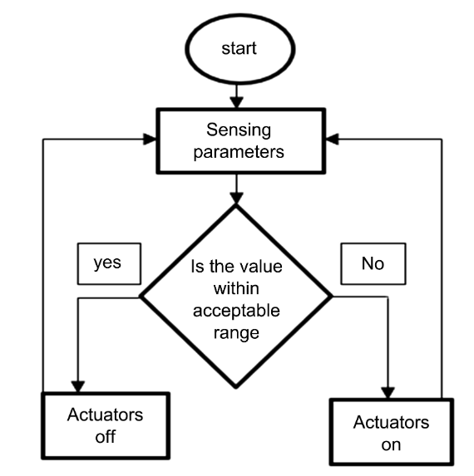

Figure 1. General flowchart of the design methodology

**Simulation**

The simulation depicted in Figure 2 of the project entails the comprehensive creation of a Smart Greenhouse Monitoring System utilizing Cisco Packet Tracer. It encompasses the integration of an array of sensors, actuators, and devices to effectively monitor and control the greenhouse environment remotely, ensuring optimal conditions for plant growth.

Commencing with the Network Setup, the simulation initiates by establishing a robust network infrastructure within Cisco Packet Tracer. This network encompasses a diverse range of devices crucial for greenhouse management, including sensors such as temperature, humidity, and CO2 detectors, along with various actuators like heaters, coolers, humidifiers, and sprinklers. Additionally, control systems are implemented to orchestrate the functionalities of these devices seamlessly.

Sensor Integration forms a pivotal aspect of the simulation, whereby different types of sensors are seamlessly integrated into the greenhouse setup. These sensors serve the vital function of monitoring key environmental parameters essential for facilitating optimal plant growth. Temperature sensors meticulously monitor temperature levels, humidity sensors gauge atmospheric moisture content, CO2 detectors track carbon dioxide levels, and soil moisture sensors assess soil hydration levels, ensuring a holistic understanding of the greenhouse environment.

Actuator Control plays a critical role in maintaining the desired environmental conditions within the greenhouse. The integration of actuators such as heaters, coolers, humidifiers, and sprinklers enable precise control over the greenhouse's microclimate. These actuators respond dynamically to the data collected by the sensors, ensuring timely interventions to uphold optimal growing conditions. For instance, in response to a decrease in temperature below a predefined threshold, the heater is activated to restore optimal warmth, while the humidifier springs into action when humidity levels dip, thus fostering an environment conducive to plant growth.

Efficient Energy Management is facilitated through the utilization of solar cells as primary energy generators within the greenhouse. Solar panels harness solar energy and convert it into electricity, which is subsequently stored in batteries for later use. This stored energy powers the various sensors, actuators, and electronic components deployed throughout the greenhouse, ensuring a sustainable and eco-friendly energy supply.

The implementation of a Smart Door System further enhances the security and functionality of the greenhouse environment. Leveraging RFID technology, the smart door system enables seamless access control, with authorized RFID cards granting entry and triggering the unlocking mechanism. In the event of unauthorized access attempts, the system promptly raises an alarm and initiates door lock-down protocols, safeguarding the integrity of the greenhouse. Additionally, the incorporation of a webcam facilitates continuous surveillance of the greenhouse entrance, further bolstering security measures.

In essence, the simulation encapsulates a holistic approach towards the development of a Smart Greenhouse Monitoring System, leveraging cutting-edge technologies to foster sustainable and efficient agricultural practices while ensuring optimal plant growth and productivity.

Steps on how to build the simulation:

1. Network Setup
   1. Set up the network topology by adding devices such as a HomeGateway and a smart device (Laptop, SmartPhone, or Tablet).
2. Integrate Sensors
   1. Add sensor devices to the greenhouse setup, including temperature, humidity, CO2, and soil moisture sensors.
   2. Configure each sensor's properties, such as sampling rate and measurement thresholds, to suit the greenhouse environment.
3. Incorporate Actuators
   1. Integrate actuators such as heaters, coolers, humidifiers, and sprinklers into the network.
   2. Configure control mechanisms to enable these actuators to respond to data collected by sensors effectively.
4. Energy Management
   1. Add solar panels to the greenhouse setup to serve as energy generators.
   2. Connect the solar panels to batteries for energy storage and distribution.
   3. Configure the system to prioritize solar energy usage and switch to battery power when necessary.
5. Implement Smart Door System
   1. Integrate RFID readers and electronic locks for the smart door system.
   2. Configure the RFID readers to recognize authorized RFID cards for entry.
   3. Set up alarm systems to trigger in case of unauthorized access attempts.
6. Connect all the devices to the HomeGateway and enable them as an IoT device
7. Setup the conditions for each individual system:

**Temperature Monitoring**

* Condition: If the temperature exceeds a certain threshold (e.g., 10°C), activate the cooling system
* Action: Turn on the cooler.
* Condition: If the temperature drops below a certain threshold (e.g., 10°C), activate the heating system
* Action: Turn on the heater.

**Humidity Monitoring**

* Condition: If the humidity drops below a certain threshold (e.g., 40), activate the humidity sysyem.
* Action: Turn on the humidifiers.

**CO2 Monitoring**

* Condition: If the CO2 level exceeds a certain threshold (e.g., 1000 ppm), activate the ventilation system to introduce fresh air.
* Action: Turn on the blower.

**Smoke Detection**

* Condition: If smoke detected
* Action: Turn on the siren and fire sprinklers

**Soil Moisture Monitoring (water level)**

* Condition: If the soil moisture level drops below a certain threshold (e.g., 30%), activate the irrigation system.
* Action: Turn on the lawn sprinklers.

**Solar Energy Management**

* Condition: If the battery level drops below a certain threshold (e.g., 20%), switch to battery power.
* Action: Switch to battery power.

**Smart Door System**

* Condition: If an authorized RFID card is detected, turn off protection.
* Action: Open door, turn WebCam off, and Turn Light on.
* Condition: If an unauthorized RFID card is detected, activate alarm system
* Action: Close the door, siren on, WebCam on, Light On.

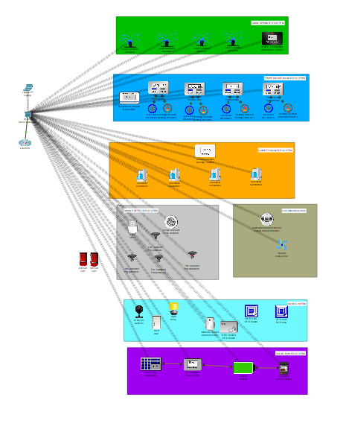

Figure 2. Project Simulation

**Conclusion**

In conclusion, the Smart Greenhouse Monitoring System offers a comprehensive solution for optimizing plant growth conditions while enhancing operational efficiency and sustainability. The simulation conducted in Cisco Packet Tracer demonstrated the feasibility and effectiveness of the proposed system architecture. By leveraging IoT technology, greenhouse operators can remotely monitor environmental parameters, automate tasks, and make data-driven decisions to improve crop yields and quality. Moreover, the incorporation of solar cells for energy generation contributes to eco-friendliness and reduces dependency on conventional energy sources. The smart door system adds an additional layer of security and access control, enhancing the overall safety of the greenhouse environment.

Overall, the Smart Greenhouse Monitoring System presents a promising approach to modernizing agricultural practices, enabling sustainable and efficient plant cultivation in controlled environments.

**Future Plans:**

Moving forward, there are several promising avenues for advancing the Smart Greenhouse Monitoring System. Integrating advanced sensors capable of monitoring nutrient levels, power of hydrogen (Ph) levels, and specific plant growth parameters can offer a more nuanced understanding of plant health and development, enabling precise adjustments to cultivation practices. Implementing machine learning algorithms to analyze sensor data could revolutionize decision-making processes by predicting optimal environmental conditions tailored to different plant species, thereby maximizing resource efficiency and yield. Additionally, conducting collaborative research with agricultural experts to customize the system according to crop-specific requirements and validating its effectiveness in real-world greenhouse settings will be crucial for ensuring its practical relevance and scalability within the agricultural industry.

**References**

[1]: K. Osita, "IOT Based Smart Greenhouse: Using Packet Tracer Software," *Open Access Library Journal*, vol. 9, pp. e9535, 2022. DOI: 10.4236/oalib.1109535

[2]: P. Tripathy, A. Tripathy, A. Agarwal, S. Mohanty., "MyGreen: An IoT-Enabled Smart Greenhouse for Sustainable Agriculture," *IEEE Consumer Electronics Magazine*, vol. PP, no. 99, pp. 1-1, Feb. 2021. DOI: 10.1109/MCE.2021.3055930.